**Task Scheduling and Types of Schedulers**

**Introduction**

Schedule the following tasks using Rate-Monotonic scheduling,

T1 {Per:5, E:2.5, D:5}

T2 {Per:15, E:4.5, D:15}

T3 {Per:20, E:3.5, D:20}

**Notes on Rate-Monotonic Scheduling: -**

1. Rate-Monotonic is a fixed priority preemptive scheduling policy.
2. Tasks priorities in Rate-Monotonic scheduling are based on tasks periodicities.

**Pros**

1. Very predictable.
2. Most optimal of all fixed priority schedulers as long as task deadline is defined as its periodicity.
3. Simple to verify schedulability.

**Cons**

1. Difficult to support aperiodic and sporadic tasks.
2. Not optimal when task period and deadline are not equal.

**Task Requirements**

1. Calculate the Rate-Monotonic Utilization Bound (Urm) of the provided task set.
2. Calculate the Time-Demand analysis for the provided task set.
3. Model the task set using Simso.
4. Provide report showing the above points with comments on results and analysis.

**Rate-Monotonic Utilization Bound (Urm)**

Assumptions for analysis

1. Only periodic tasks.
2. Deadline equals task periodicity.
3. Zero context switching time.

**CPU Load Calculation**

Hyperperiod = LCM [5,15,20] = 60

$CPU Load= \frac{\sum{\frac{Hyperperiod*ExecutionTime}{Periodicity}}}{Hyperperiod}$ = $\frac{\frac{60*2.5}{5}+\frac{60*4.5}{15}+\frac{60*3.5}{20}}{60}=0.975=97.5\%$

**Urm equation**

System is considered feasible if $CPU Load≤N [2^{\frac{1}{n}}-1]$ for CPU Load < 100%, N is number of tasks.

Utilization Bound = $3 \left[2^{\frac{1}{3}}-1\right]= 0.77976$

**Urm equation – Notes**

1. CPU Load is exceeding the utilization bound, hence is not schedulable.

**Time-demand Analysis**

Assumptions for analysis

1. Only periodic tasks.
2. Deadline is smaller than or equals task periodicity.
3. Zero context switching time.

**Task response time**

In real-time systems the response time of a task or thread is defined as the time elapsed between the dispatch (time when task is ready to execute) to the time when it finishes its job (one dispatch).

**Time-demand Analysis Equation**

$w_{i}\left(t\right)=E_{i}+\sum_{k=1}^{i-1}{⌈\frac{t}{P_{k}}⌉*E_{k}}$ at 0<t $≤P_{i}$

W: worst response time E: execution time P: periodicity t: time instance

|  |  |  |  |
| --- | --- | --- | --- |
| D | D1 = 5 | D2 = 15 | D3 = 20 |
| t | $$w_{1}\left(t\right)=E_{1}$$ | $$w_{2}\left(t\right)=E_{2}+⌈\frac{t}{P_{1}}⌉*E_{1}$$ | $$w_{3}\left(t\right)=E_{3}+\left\lceil \frac{t}{P_{2}}\right\rceil *E_{2}++⌈\frac{t}{P_{1}}⌉*E_{1}$$ |
| 1 | 2.5 | 7 | 10.5 |
| 2 | 2.5 | 7 | 10.5 |
| 3 | 2.5 | 7 | 10.5 |
| 4 | 2.5 | 7 | 10.5 |
| 5 | 2.5 | 7 | 10.5 |
| 6 |  | 9.5 | 13 |
| 7 | 9.5 | 13 |
| 8 | 9.5 | 13 |
| 9 | 9.5 | 13 |
| 10 | 9.5 | 13 |
| 11 | 12 | 15.5 |
| 12 | 12 | 15.5 |
| 13 | 12 | 15.5 |
| 14 | 12 | 15.5 |
| 15 | 12 | 15.5 |
| 16 |  | 22.5 |
| 17 | 22.5 |
| 18 | 22.5 |
| 19 | 22.5 |
| 20 | 22.5 |

**Time-demand Analysis – Notes**

1. Task3 is exceeding its deadline hence task set is not schedulable.

**SIMSO Simulation – Gantt Chart**

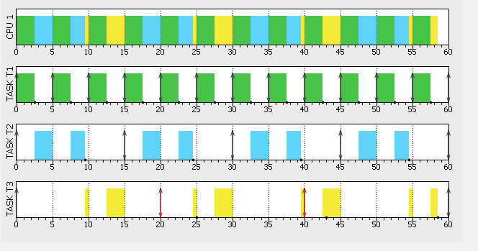

**SIMSO Simulation – Gantt Chart Notes**

1. Task3 will miss deadline confirming manual analysis.

**SIMSO Simulation – Results**

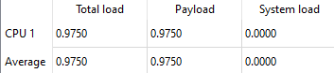

**SIMSO Simulation – Results – Notes**

1. CPU load as calculated manually.